TITLE: COVID-19 Policy and Procedure POLICY X.

Department/Area: Milwaukee LGBT Community Center
Date of Initial Approval: 02/02/2023
Date of Review: 11/28/2023
Date of Revision: 11/28/2023
Approved By: Ritchie T. Martin, Jr.

SCOPE: COVID-19 remains a serious health risk and the Milwaukee LGBT Community Center remains committed to practices to reduce its impact on employees, those we serve, and the community. The Wisconsin Department of Health has updated the definition of a COVID-19 outbreak to be at least 3 cases in a 7-day period. The State and local COVID-19 health emergencies have ended. The Milwaukee LGBT Community Center is moving away from more restrictive measures and is aligning further with CDC recommendations.

All departments, services and programs of the Milwaukee LGBT Community Center must adopt and follow the requirements in the policy as outlined below, including contractors and volunteers.

- Definitions
- Close Contact: A person with Close Contact is someone who:
- Was within 6 feet of an infected person for a cumulative total of 15 minutes or more over a 24-hour period starting from 2 days before infected person’s illness onset (or, for an asymptomatic infected person, 2 days prior to test specimen collection) until the time the infected person is isolated. This is the definition regardless of whether face masks or personal protective equipment (PPE) were worn by any or all individuals, and/or
- Provided care at home to an infected person; and/or
- Had direct physical contact with an infected person (touched, hugged, or kissed them); and/or
- Shared eating or drinking utensils with an infected person; and/or
- Got respiratory droplets (for example, was sneezed or coughed on) on them from an infected person.
- Confirmed Case of COVID-19: A case of COVID-19 that has been confirmed through a positive test for COVID-19.
- Exposure to COVID-19 (Exposure): Any form of Close Contact (see A. above) with an individual who has a Confirmed Case of COVID-19 during the last 14 days.
- Fully Vaccinated:
i. An individual has received two vaccinations in a two-dose vaccine series or one
vaccination in a single-dose vaccine, AND
ii. Two weeks or more have passed since the individual received the final dose.
- Up-to-date Vaccinations:
i. Up to date refers to an individual who has received two vaccinations in a two-dose vaccine series or one vaccination in a single dose vaccine, AND
ii. Has received one booster shot vaccine
- Isolation: Isolation keeps someone who is infected with the virus away from others, even in their home.
- Not Up to Date with Vaccinations: Individuals who:
i. Have not received the second shot of a two-dose vaccine despite being eligible for
a second shot (more than 3 weeks since initial Pfizer vaccination or since the
initial Moderna vaccination) OR
ii. Have not received a booster shot despite being eligible for a booster (more than
two months since single dose of Johnson & Johnson vaccination or at least five
months since second dose of Pfizer or Moderna vaccination)
- Symptomatic Individual: Any person who has Symptoms Compatible with COVID-19. This could include employees, contractors, visitors, or people in the community.
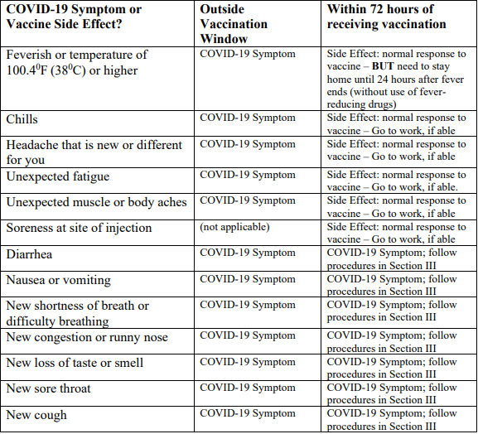
- Symptoms Compatible with COVID-19 (Symptoms): Symptoms may appear from 2 to 14 days following exposure. Also see the CDC self-check tool for identifying COVID-19 symptoms. Note that in the 72 hours following a dose of COVID-19 vaccine, common side effects of the vaccines may mimic some COVID-19 Symptoms but should be treated as Side Effects, not Symptoms, as indicated below.

- Test for COVID: Two tests are commonly used to diagnose COVID-19: PCR (polymerase chain reaction) tests and rapid (or antigen) tests. Both are used to determine if the virus that causes COVID-19 is currently present in an individual.
i. PCR tests, which are analyzed in laboratories and usually take from one to three
days for results, are highly accurate and considered the “gold standard” test.
ii. Rapid tests may be analyzed outside labs and may yield results as soon as a few
minutes after testing. Rapid tests are most accurate in identifying positive cases
of COVID-19 when symptoms are present; negative rapid test results may be less
conclusive. For more information, visit the CDC website.
iii. Note that antibody tests are blood tests that determine if an individual has had a
past infection of COVID-19 but are not used to diagnose current infections.

- What to do when an employee, contractor, or recent visitor has a Confirmed Case of COVID-19

This section provides guidance to employees who have a Confirmed Case of COVID-19. It also provides guidance to supervisors of these individuals as well as to supervisors where a recent contractor or visitor has a Confirmed Case of COVID-19. In no instance is this guidance meant to replace or override the advice of a medical professional.

NOTE: An individual’s vaccination status does not affect the required responses if the individual contracts a Confirmed Case of COVID-19. The variable that affects these requirements are whether the individual develops Symptoms.

- For Employees with Confirmed Case of COVID-19
- If an employee has a Confirmed Case of COVID-19, they should notify their supervisor immediately.
- The employee should provide to their supervisor confirmation of their positive test result or confirmation from medical personnel of the Confirmed Case of COVID-19 as soon as it can be reasonably obtained. (A photo and or screenshot is permissible so that the employee does not come into physical contact with the Milwaukee LGBT Community Center and other employees.
- Medical advice to the employee should come from a medical doctor or public health authority.
- The employee should follow the guidance on isolation from the CDC.
- If remote work is possible, isolating employee may remote work with direct approval from the department director. If remote work is not an option, the employee may use Sick Time or other paid time off (PTO). NOTE: If the employee is in a negative balance for PTO or Sick Time, the Department Director must communicate to the Executive Director and or their designee the employee’s negative balance and Executive Director will navigate with the Director balance occurrences.
- Supervisors should, as possible, identify employees, contractors, and community members who had Exposure to the individual with the Confirmed Case of COVID19 in the 48 hours prior to the onset of symptoms through the time of the positive test or medical confirmation.
- If the individual with the Confirmed Case of COVID-19 is asymptomatic, identify people who had Exposure to the individual in the 48 hours prior to the time the test specimen was collected.

- Return to Work Procedure for Employees with a Confirmed Case of COVID-19
Unless otherwise directed by their health care provider, employees with a confirmed case of COVID-19 should follow these guidelines and procedures for returning to work:
- Employees with a Confirmed Case of COVID-19 who developed Symptoms and were directed to isolate themselves at home may return under the following conditions:
- Stayed home for at least 5 days and isolated from others in their home. One is likely most infectious during these first 5 days.
- End isolation after day 5 if you are fever free for 24 hours (without use of fever-reducing medication, and
- Symptoms are improving.

- What to do when an employee calls in sick with Symptoms, reports to work with Symptoms, or develops Symptoms while at work

- CDC is confident that the number of people with COVID-19 is higher than the number of known positive cases. While symptoms compatible with COVID-19 are an imperfect proxy for someone being infected, Symptoms can be used to inform preventative measures to contain the spread of the virus.
- If employees experience any Symptoms, they should stay at home or, if at work, return home following the immediate directions below. Any Symptomatic community members or visitors should also return home immediately, following this guidance.
Revocation of Vaccination Requirements:
Agency Policies adopted to implement The Milwaukee LGBT Community Center COVID Policy on 02/02/2023 are revoked. Considering the Milwaukee LGBT Community Center moving beyond COVID-19 policies adopted on 02/02/2023 and based on the guidance from our Public Health experts, we no longer need employee vaccination requirements for Milwaukee LGBT Community Center employees. Vaccinations remain an important tool to protect individuals from serious illness, but we are now able to move beyond adopted policies and requirements. The Milwaukee LGBT Community Center basis its policies

